Name: Pranali Sonawane
Subject: CCNA
Date: 20-11-2025
Lab 29– : Static NAT
First, take two routers (for example, 1841 models), two switches, and four PCs.Connect the routers, switches, and PCs using straight-through cables.Use a crossover cable to connect the FastEthernet interfaces between the two routers.

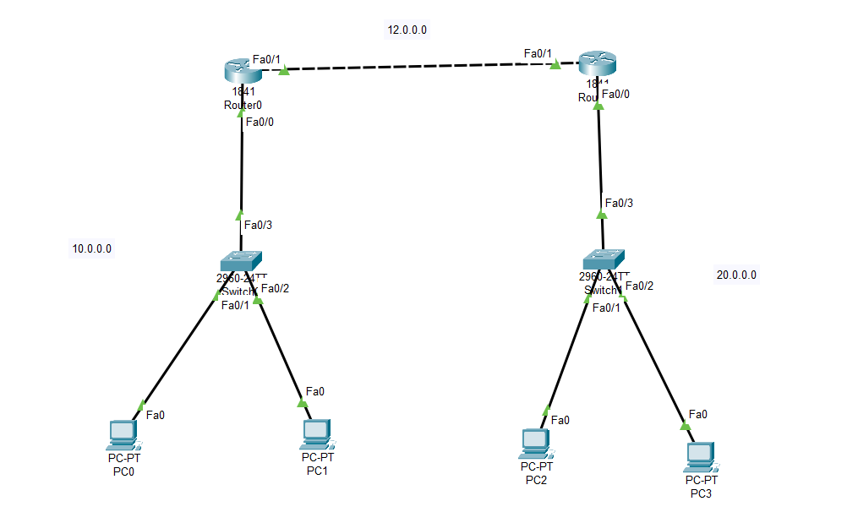
Open Router 0 – CLI prompt then type following commands
Router>enable
Router#configure terminal
Router(config)# interface fastEthernet 0/0
Router(config-if)# ip address 10.0.0.1 255.0.0.0
Router(config-if)#no shutdown
Router(config-if)#exit

Router(config)#interface fa0/1
Router(config-if)#ip address 12.0.0.1 255.0.0.0
Router(config-if)#no shutdown
Router(config-if)#exit

Router(config)# router ospf 1
Router(config-router)# network 10.0.0.0 0.255.255.255 area 0
Router(config-router)# network 12.0.0.0 0.255.255.255 area 0
Router(config-router)# exit
Router#show ip route
Router#show ip os nei
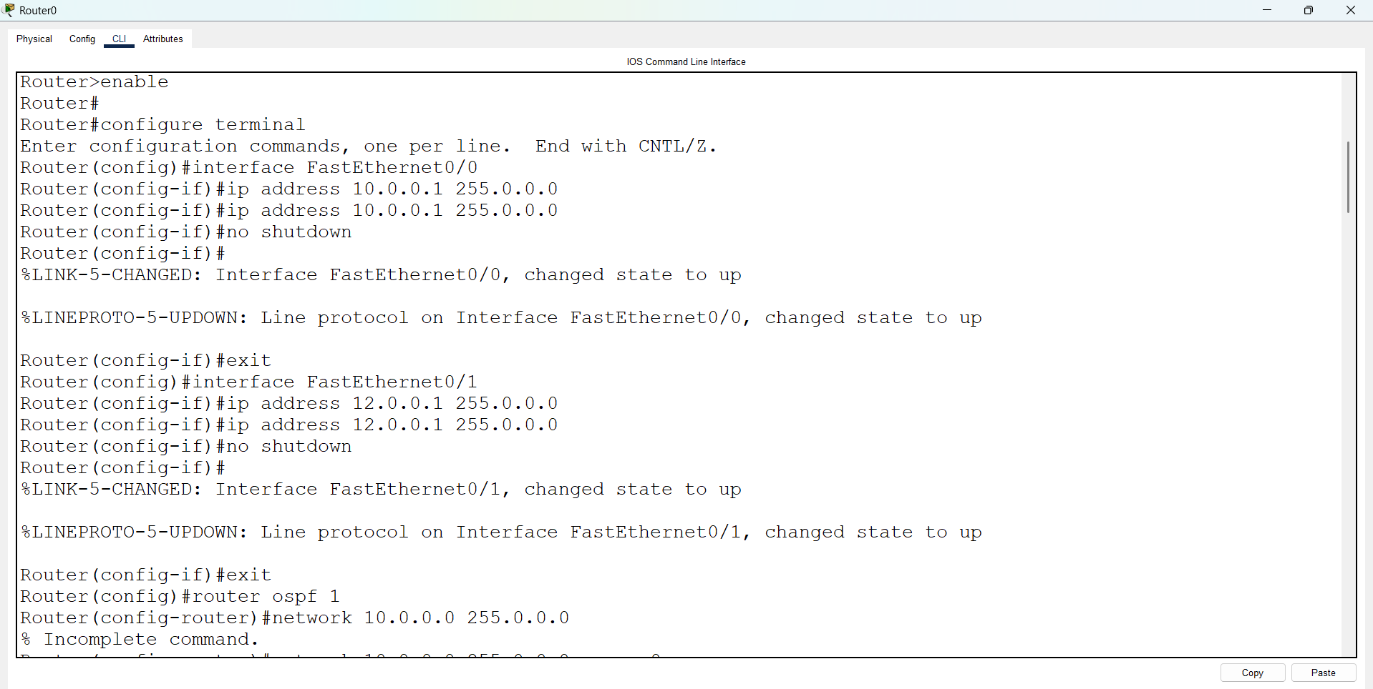
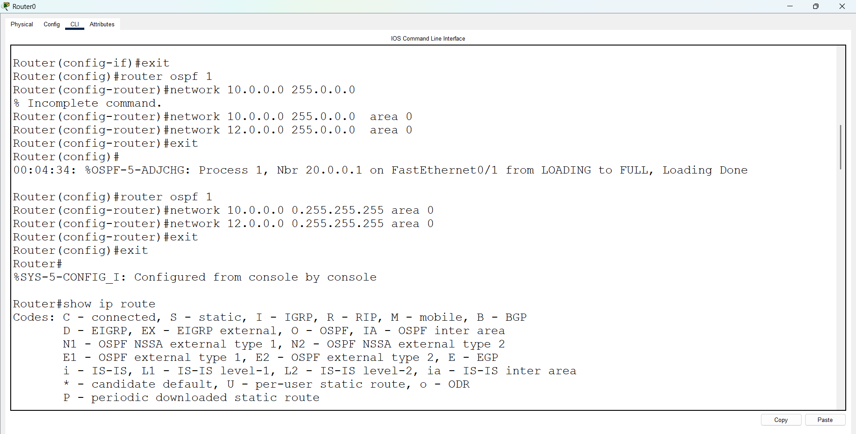
Open Router 1 – CLI prompt then type following commands
Router>enable
Router#configure terminal
Router(config)# interface fastEthernet 0/0
Router(config-if)# ip address 20.0.0.1 255.0.0.0
Router(config-if)#no shutdown
Router(config-if)#exit

Router(config)#interface fa0/1
Router(config-if)#ip address 12.0.0.2 255.0.0.0
Router(config-if)#no shutdown
Router(config-if)#exit

Router(config)# router ospf 1
Router(config-router)# network 20.0.0.0 0.255.255.255 area 0
Router(config-router)# network 12.0.0.0 0.255.255.255 area 0
Router(config-router)# exit
Router#show ip route
Router#show ip os nei
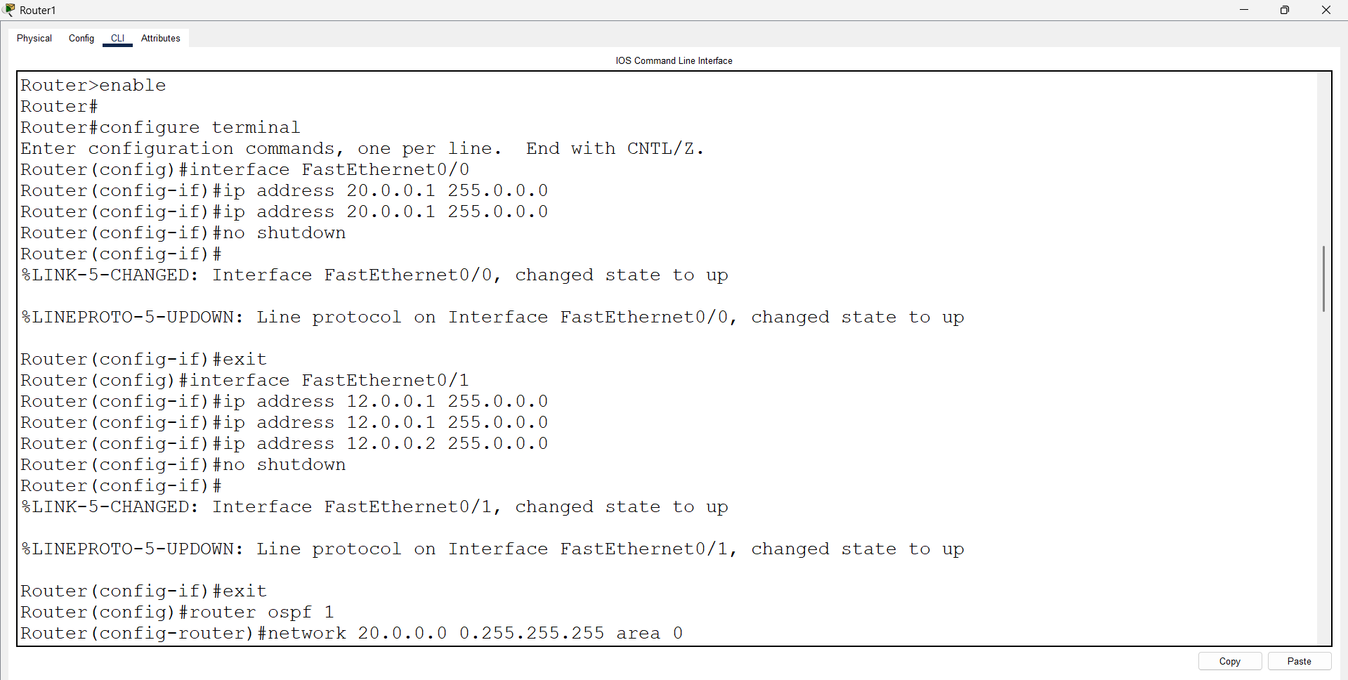
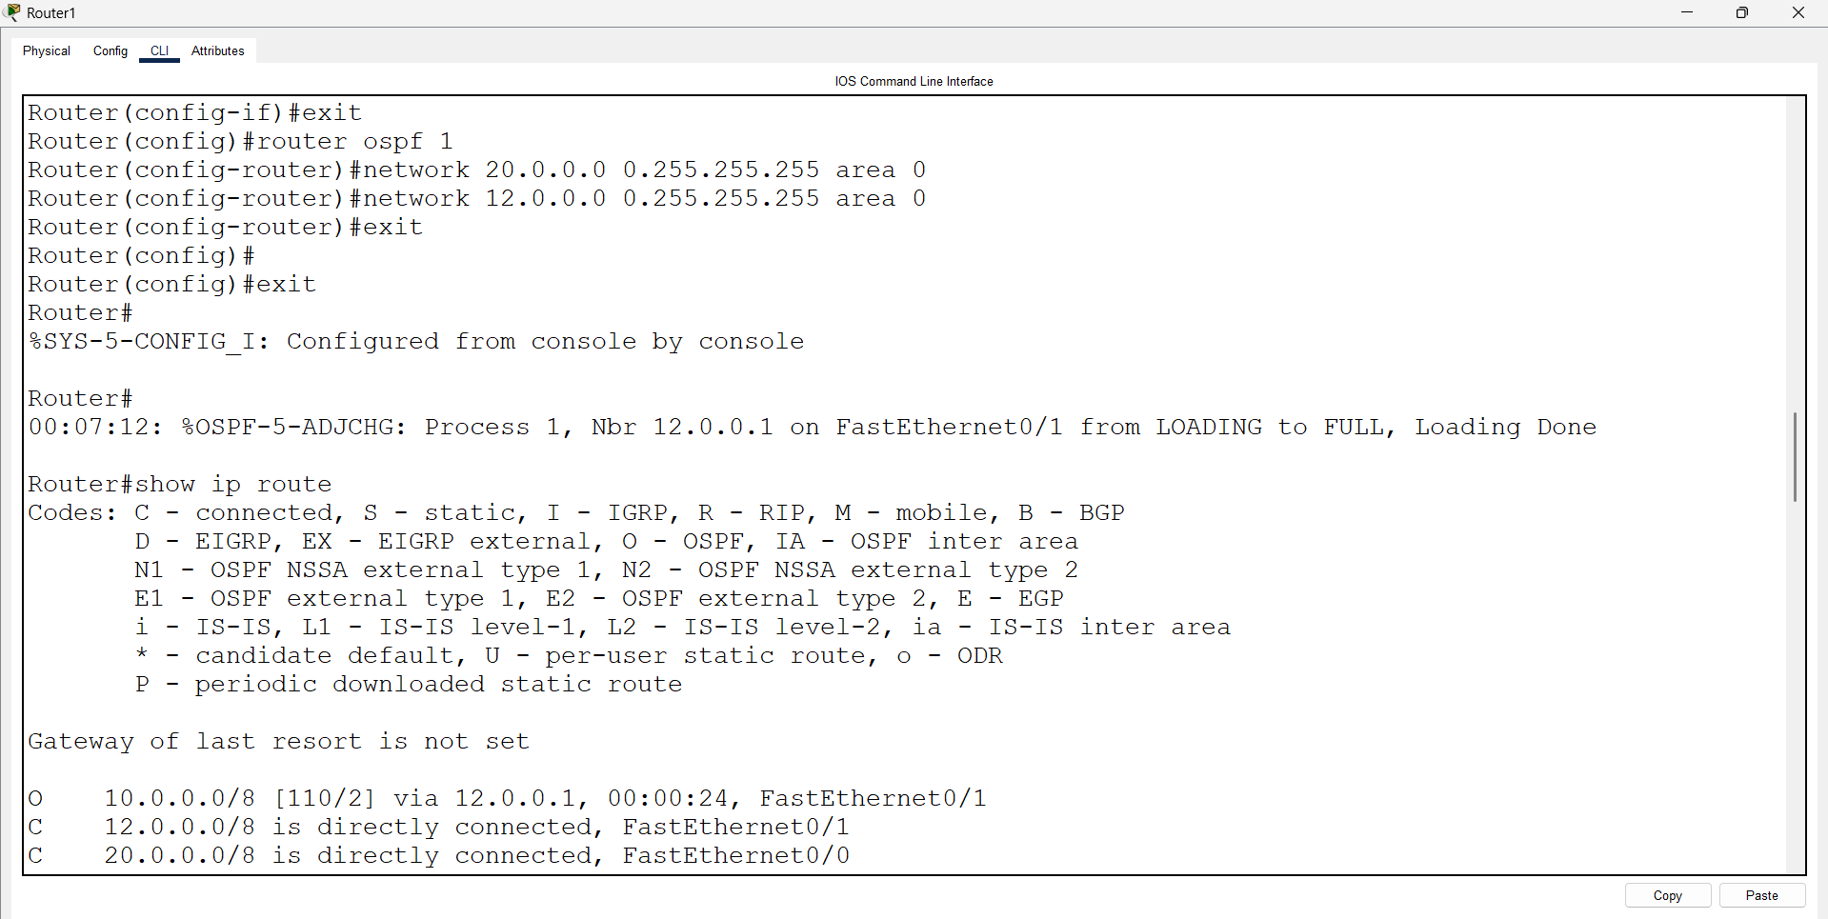

Static NAT Commands:
Open Router 0 – CLI prompt then type following commands
Router >en
Router#config t
Router(config )#access-list 1 permit 10.0.0.0 0.255.255.255
Router(config)#ip nat inside source 10.0.0.2 12.0.0.3
Router(config)int fa0/0
Router(config-if)#ip nat inside
Router(config-if)#exit
Router(config)int fa0/1
Router(config-if)#ip nat outside
Router(config-if)#exit
Router# show ip nat translation
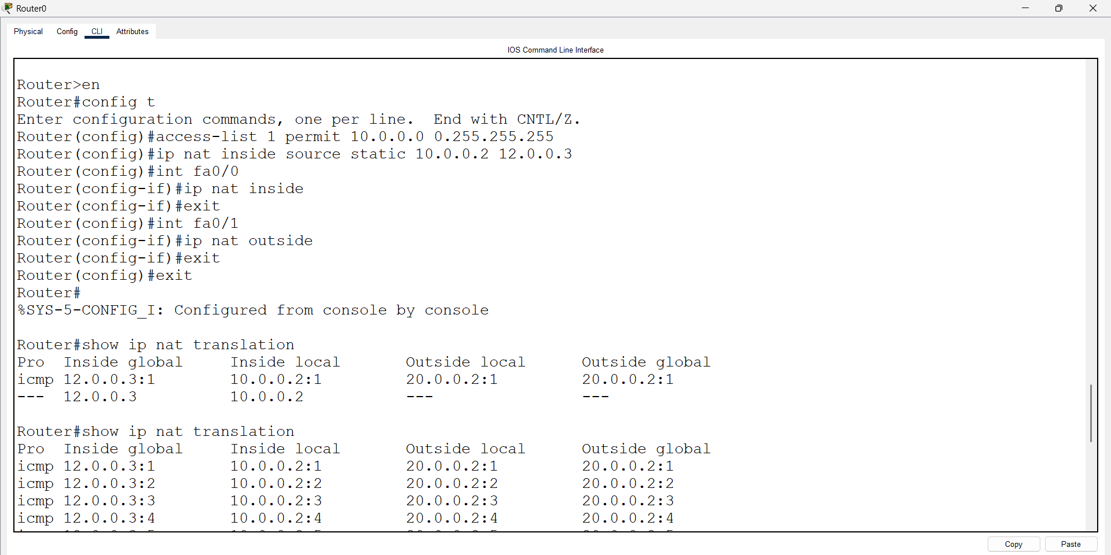
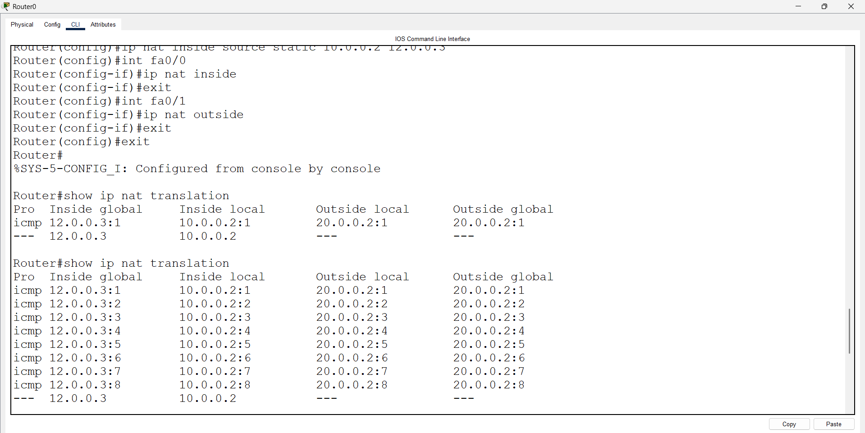
Router >en
Router#config t
Router(config)#ip nat inside source 10.0.0.3 12.0.0.3
Router(config-if)#exit
Router# show ip nat translation
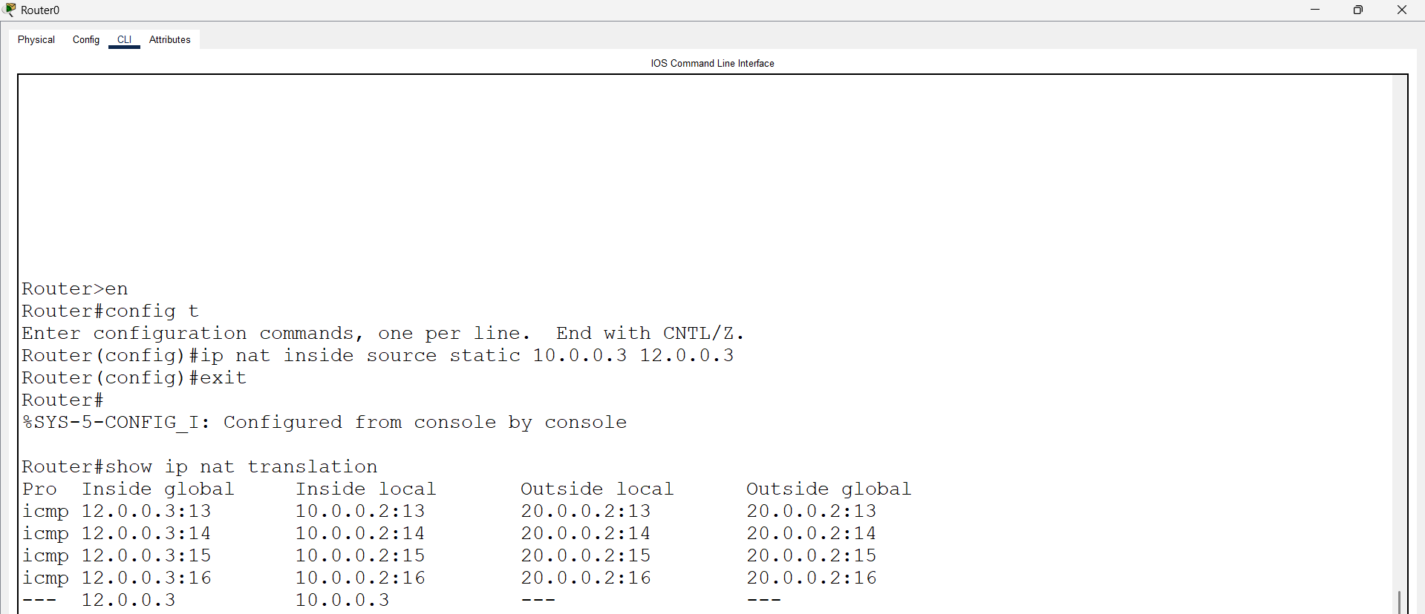

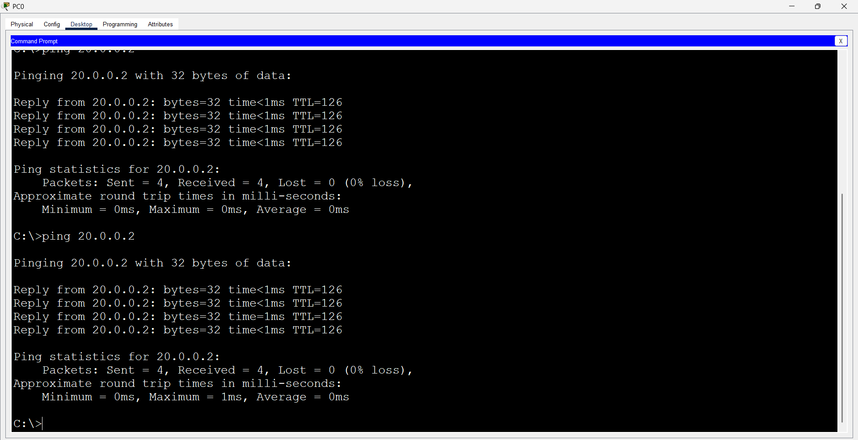
Then Remove the Access-list and All :

Open Router 0 – CLI prompt then type following commands
Router(config )#no access-list 1 permit 10.0.0.0 0.255.255.255
Router(config)#no ip nat inside source 10.0.0.2 12.0.0.3
Router(config)int fa0/0
Router(config-if)#no ip nat inside
Router(config-if)#exit
Router(config)int fa0/1
Router(config-if)#no ip nat outside
Router(config-if)#exit
Do the Dynamic NAT

Check :
Router#show running-config | include ip nat inside source static
Router(config )#no ip nat inside source static 10.0.0.3 12.0.0.3

